A web-based alternative to Scratch

Lead Image © jirawat phueksriphan, 123RF.com

It's a Snap
Paul Brown
Although Scratch is great, a lot can be said for Snap!, Scratch's cloned, web-based little brother. Written in JavaScript, Snap! can be run within a web browser and is easily extended with some XML and Python-Fu.
Educational programming tools are all the rage. Educators and computer scientists agree that the current computer science curriculum – as in "teaching students how to use Word, Excel, and PowerPoint" – is a woefully inadequate way of getting students interested in computers and does nothing to help develop real-life computer engineering skills.
Also, a growing school of thought proposes that computer programming should become a core part of children's education, much the way English and mathematics are now. Not to turn all kids into computer scientists, but because programming is an excellent way to develop logical reasoning and math-related skills that are not so easily acquired via other subjects.
That's why stuff like the original Squeak Etoys [1], which later morphed into Scratch [2], exist. Scratch has become the staple educational software for the Raspberry Pi, the staple educational hardware, and has generated several clones. One of these clones is called Snap! [3], and it's interesting for several reasons. First, it is written entirely in JavaScript. This means you can run it in a web browser (albeit not any web browser and on any platform, as you will see later) with no extra software needed (Figure 1). This also means it's cross-platform. Regardless of whether your computer runs GNU/Linux, Mac OS X, Windows, or whatever, if it has a modern, JavaScript-enabled browser, such as Firefox, Chrome/Chromium, Midori, and the like, Snap! will work on it.
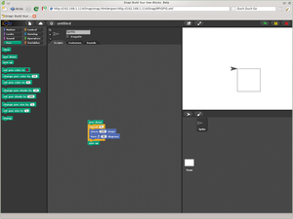 Figure 1: Snap! is a JavaScript implementation of Scratch that works in a web browser.
Second, Snap! is easily modified and extended: You can build your own blocks, and you do so just by right-clicking on the workspace and selecting make a block from the pop-up menu. This approach leads to some interesting possibilities and has made Snap! the tool of choice for educational projects that need their own, tailor-made, visual programming language. Currently, Snap! extensions are available for the NXT/Lego Mindstorms hardware, the Hummingbird educational development board, the Arduino, and so on.

Heavy Lifting
Interestingly, there is no Snap! extension for the Raspberry Pi – probably because of the caveat regarding using such a JavaScript-heavy language. In it's current state of development, it is practically unusable on the Pi. If you try to open a web page containing an instance of Snap! in your Pi, your CPU load indicator will become a solid block of green and will stay that way until you close the page. Meanwhile, everything on your Pi will become slow and laggy. Dragging and dropping blocks onto the workspace is a painful procedure that can take up to 20 seconds to register on the visual interface. Clearly, Scratch is the superior alternative if you are working directly on the Pi.
So, why bother with Snap! at all? After all, Scratch is, er, snappier, and it has already been adapted to the hardware. But, there are reasons to use Snap!. I already listed two reasons above – namely, it's ridiculously cross-platform and is very easy to expand. A third reason, derived from the first, is that, if you set up a Snap! server on your Raspberry Pi, for example, you can program your Pi, including its GPIOs, remotely, even from your smartphone (Figure 2). How cool is that?
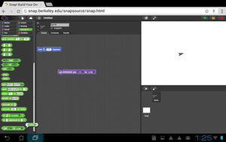 Figure 2: Snap! works happily on most smart mobile devices, such as smartphones and tablets.
Then, of course, there's the "we-do-it-because-we-can" reason, which should resonate with a lot of readers.

Light Speed
Using the Pi as a Snap! server still makes sense. Even if it is not currently practical to code Snap! directly on the Pi, you can leverage Snap!'s elegant approach to language extension and assemble your scripts from another computer that can handle the heavy JavaScript load. With a bit of Python and XmlFu, you can also access most, if not all, of the Rasp Pi's unique characteristics – namely, its I/O pins.
Unfortunately, how you go about doing this is woefully (and unsurprisingly) undocumented. To quote the current Snap! 4.0 manual: "The idea is that you run a separate program that both interfaces with the device and provides a local HTTP server that Snap! can use to make requests to the device."
And, apart from a vague promise that the situation will improve with time, that's it.
In this article, I'll shed some light on how all this is done. I'll start by running a version of Snap! on the Pi and have the Pi act as a server. Later, you'll see how to create an extension that uses the Rasp Pi's bits and pieces.
First, you can grab all the files you need to run a stock version of Snap! on your local network, either by using Git,
$ git clone https://github.com/jmoenig/Snap--Build-Your-Own-Blocks.git
or by grabbing the ZIP file from the GitHub page [4] with the Download ZIP button.
If you already have a web server running on your Pi, make a Snap directory in the server's root and copy the files you will find in the Snap download directory to it.
$ sudo mkdir /var/www/Snap
$ sudo cp -Rv Snap--Build-Your-Own-Blocks/* /var/www/Snap/
Then, point your browser on your other computer to http://<RPi's IP>/Snap/snap.html, and you're good to go. You can skip to the next section.
If you're not running your own web server, doing so is dead easy. A good choice is lighttpd because, as its name suggests, it's very light and will not overload your Pi. Besides, for serving a bunch of JavaScript, it's all you'll need.
Open a terminal window and type:
$ sudo apt-get lighttpd
Once installation is finished, the server will already be running. You can check by pointing Midori on your Pi to 127.0.0.1 (or, from another computer, pointing your web browser to your Pi's IP). If you see something like what is shown in Figure 3, everything is fine.
Figure 3: You can use lightt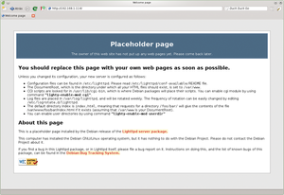pd, a lightweight web server, on your Pi to serve up Snap! on your local network.
Once lighttpd is installed, you can copy the Snap! files to your web directory as explained above.

Building Blocks
You can easily create new blocks in Snap! by right-clicking on the central workspace and choosing Make a block from the pop-up dialog. Snap will then bring up a wizard like you see in Figure 4.
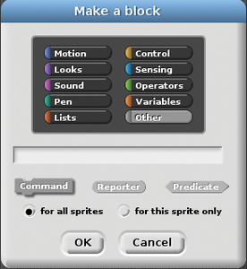 Figure 4: The Make a block wizard allows you to extend Snap!.
You can decide which category your block will go under and whether it will be a Command (executes a series of instructions without returning a value), a Reporter (executes a sequence of commands and returns a value), or a Predicate (similar to a Reporter, but returns a True or False to be used in conditions).
Because you will be seeing examples of how to build a Command and a Predicate later when I get into reading and writing to the Pi's GPIOs, I'll first demonstrate how to create a Reporter. In this exercise, you will create a block that, given a positive integer number, returns its factorial (n! = 1 x 2 x 3 x 4 x … x n).
Within the wizard window, click on the Operators button, because that is where you are going to store your block. In the text box, type !. This will appear as text on the block itself. Next, click Reporter and then OK.
You will see something like what is shown in Figure 5. The two plus signs on either side of your ! are placeholders for more text or parameters. In this case, you're going to click on the first +. A new dialog will pop up (Figure 6), and you must type number in the text box and select Input name (i.e., parameter). Then, click the little right-pointing arrow to the right. This will unfold a much larger dialog that allows you to pick the parameter's type (Figure 7). Choose Number and click OK.
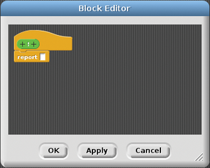 Figure 5: You use the editor to build functions and routines.
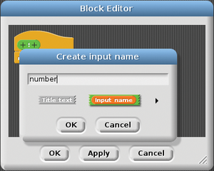 Figure 6: A new wizard allows you to add more elements to the block definition.
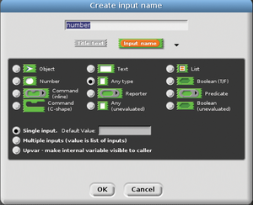 Figure 7: The Create input name dialog lets you set a parameter's name and type.
Now you have the definition, but the block doesn't actually do anything yet. You're going to need a new variable for that; so, in your workspace, click on Variables and then on Make a variable. Call your new variable result.
Then, within the Block Editor, build a script like the one in Figure 8.
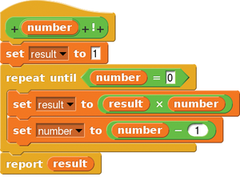 Figure 8: The factorial block code.
When you're done, click OK and your block will appear under Operators.
Now you can drag the block out onto the workspace. Click within the number slot and type, for example, 5. Next, click on the block and the result (120) should show up in a bubble in the workspace and in a lozenge in the upper left-hand corner of the stage at the upper right (Figure 9).
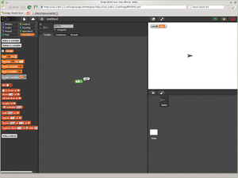 Figure 9: The result of your block will show up as a speech bubble in the workspace.
This factorial block is just a dumb example that does not work very well. If you were to input a , a negative number, or a number with decimals, it would fail miserably. You can experiment with improving it by taking all those possibilities into account.
When you're done, if you want to save your block, click on the File button (the paper icon with the folded corner) in the toolbar and select Export blocks. Select the blocks you want to export from the list and click OK. A new window or tab will open in your browser with something that looks like Listing 1.
Listing 1
Factorial.xml
01 <blocks app="Snap! 4.0, http://snap.berkeley.edu" version="1">
02 <block-definition s="%'number' !" type="reporter" category="operators">
03 <header/>
04 <code/>
05 <inputs>
06 <input type="%n"/>
07 </inputs>
08 <script>
09 <block s="doSetVar">
10 <l>result</l>
11 <l>1</l>
12 </block>
13 <block s="doUntil">
14 <block s="reportEquals">
15 <block var="number"/>
16 <l>0</l>
17 </block>
18 <script>
19 <block s="doSetVar">
20 <l>result</l>
21 <block s="reportProduct">
22 <block var="result"/>
23 <block var="number"/>
24 </block>
25 </block>
26 <block s="doSetVar">
27 <l>number</l>
28 <block s="reportDifference">
29 <block var="number"/>
30 <l>1</l>
31 </block>
32 </block>
33 </script>
34 </block>
35 <block s="doReport">
36 <block var="result"/>
37 </block>
38 </script>
39 </block-definition>
40 </blocks>
You can now save this file as Factorial.xml and later import it back into Snap! using the Import option in the File menu.
Notice how clever this is: All the individual blocks that make up your custom block are contained within this XML file. For example, the section
<block s="doSetVar">
<l>number</l>
<block s="reportDifference">
<block var="number"/>
<l>1</l>
</block>
</block>
contains the part that decrements the number variable by one.

Hello (Outside) World
If you want Snap! to interact with the hardware, things get a little stickier. JavaScript, by design and for security reasons, is not allowed to interact with a machine's hardware. Browsers execute JavaScript scripts within a virtual and airtight sandbox to prevent evildoers from messing with your computer from the web.
How do you overcome this limitation? As usual, with Snap! – very cleverly as it turns out. JavaScript can't interact with hardware directly, granted, but it can interact with other web servers, sending data to them using the GET method, and it can also receive data back in the shape of web pages. Finally, a web server can interact with the underlying hardware (and other non-web software) it is running on.
So, you need to set up a web server on your Rasp Pi. Snap! sends a GET request with parameters to the server. The server interacts with the hardware, reading or writing to the GPIOs and then, if required, builds a dynamic web page to send back to Snap!. Next, Snap! extracts the data from the page and uses it in its program. You can see a summary of how this works in Figure 10.
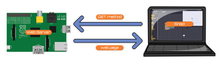 Figure 10: Snap! interacts with web servers running on the hardware to send and receive information.
I'll clarify how this would go down on the Rasp Pi with a real-life example. First, open the block editor and create a Command block like the one shown in Figure 11. This block will send a HIGH or LOW signal to a certain GPIO pin. You can use this to switch an LED on or off, for example. You can see what the block's internal design would look like in Figure 12 and the corresponding XML in Listing 2.
 Figure 11: This block will set the state of a pin on the Raspberry Pi.
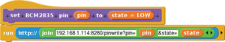 Figure 12: What the block in Figure 11 looks like "from the inside."
Listing 2
pinwrite.xml
01 <blocks app="Snap! 4.0, http://snap.berkeley.edu" version="1">
02 <block-definition s="set BCM2835 pin %'pin' to %'state'" type="command" category="looks">
03 <header/>
04 <code/>
05 <inputs><input type="%n" readonly="true"><options>0
06 1
07 4
08 7
09 8
10 9
11 10
12 11
13 14
14 15
15 17
16 18
17 21
18 22
19 23
20 24
21 25</options></input><input type="%txt" readonly="true">LOW<options>LOW
22 HIGH</options></input></inputs>
23
24 <script>
25 <block s="doRun">
26 <block s="reportURL">
27 <block s="reportJoinWords">
28 <list>
29 <l>192.168.1.114:8280/pinwrite?pin=</l>
30 <block var="pin"/>
31 <l>&state=</l>
32 <block var="state"/>
33 </list>
34 </block>
35 </block>
36 <list></list>
37 </block>
38 </script>
39 </block-definition>
40 </blocks>
You may notice something in the XML that is not visible in the Snap! block definition of the command: A list of possible values for your two parameters. Here, pin can take only the numbers that designate valid GPIO pins on the RPi you can write to, and state can take LOW and HIGH as values (the default value being LOW).
To assign a list of options to a parameter, right-click on your block and choose edit from the pop-up dialog to open the block editor. Click the parameter you want to change (e.g., pin or state) and then the right-pointing arrow in the Edit input name dialog.
In this extended dialog, make sure you have the Single input radio button selected at the bottom. Right-click on the Default Value text box to open a new pop-up menu (Figure 13). Clicking options lets you input your options, one per line (Figure 14). Finish by clicking OK. If you want to make sure your user only inputs something from your list and doesn't type anything else, right-click the Default Value text box again and mark the read-only checkbox.
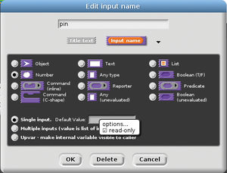 Figure 13: Right-clicking on the Default Value text box lets you …
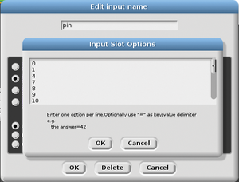 Figure 14: … access the Input slot Options, where you can specify the options to use for your block's parameters.
You might also notice that the block calls http://192.168.1.114:8280/…. That's the server running on the Rasp Pi, and 192.168.1.114 is the IP of my Raspberry Pi on my local network. You will have to change that to whatever your Pi's IP is on your network.

Coming Up!
Next, you need to create a server on your Pi to field your block's query. As usual, Python to the rescue! Python is great for this task because, apart from having a comprehensive module for dealing with the Pi's GPIO pins, it also has a simple web server module that has everything you need to grab and answer petitions coming from Snap!.
Take a look at Listing 3. Note that this is only a fragment of the whole RPiGPIO.py server program. You can find the complete program online [5], but what is shown here (and in Listing 4) is the skeleton of what you need to set up a web server to listen on port 8280 on your Pi.
Listing 4
RPiGPIO.py – Request Handler
01 .
02 .
03 .
04 class CORSHTTPRequestHandler(SimpleHTTPServer.SimpleHTTPRequestHandler):
05 def send_head(self):
06 path = self.path
07
08 self.pin=0
09 self.state=False
10
11 GPIO.setmode(GPIO.BCM)
12
13 ospath = os.path.abspath('')
14
15 regex = re.compile(".*pin=([0-9]*).*state=(LOW|HIGH)")
16 m = regex.match(path)
17
18 if 'pinwrite' in path: # write HIGH or LOW to pin
19
20 self.pin = int(m.group(1))
21 self.state = True
22 if m.group(2) == 'LOW':
23 self.state = False
24
25 GPIO.setup(self.pin, GPIO.OUT)
26 GPIO.output(self.pin, self.state)
27 .
28 .
29 .
Listing 3
RPiGPIO.py – Server Setup
01 #!/usr/bin/python
02
03 import SimpleHTTPServer
04 import SocketServer
05 .
06 .
07 .
08 if __name__ == "__main__":
09 PORT = 8280 #R+P in ASCII Decimal
10 Handler = CORSHTTPRequestHandler
11
12 httpd = SocketServer.TCPServer(("", PORT), Handler)
13
14 print "serving at port", PORT
15 print "Go ahead and launch Snap!"
16 httpd.serve_forever()
In your command (Figure 12), note how the second block runs a call to your server. Suppose you want to send a HIGH signal to pin 17 on your Pi, then the final string sent to the RPiGPIO.py server will look like:
http://192.168.1.114:8280/pinwrite?pin=17&state=LOW
Now you need to write into your server the bit that is missing from Listing 3 – namely, a request handler that breaks up the requests that Snap! sends and then executes anything that needs doing on the hardware. Listing 4, another piece of the whole program [5], does exactly that.
You use regular expressions to break up the string you saw earlier and extract the pin you want to change (lines 15 and 16) and the state you want to change it to (21 and 23). You then use the regular GPIO calls from the RPI.GPIO module to set the pins and send out the signal.
You can check how this works by setting up a circuit like the one shown in Figure 15 (note the 10K resistor – important later). Download the code [5], copy the RPiGPIO.py server over to your Pi, and run it with:
$ sudo python RPiGPIO.py
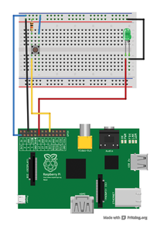 Figure 15: Use this circuit to test your scripts and the server.
Next, import RPiGPIO.xml into Snap!. You will find the block you just created under Looks. Drag it onto the workspace, right-click on it, and choose edit from the pop-up dialog. Change the IP address (currently, 192.168.1.114) to whatever your Rasp Pi's IP is on your network and then click Apply and OK.
Choose 17 for the pin value, and HIGH for the state value. Click the block and watch the LED light up.

Buttoned Up
In the last example, I'll show how to implement a block that not only sends information over to the Pi, but also gets a response back. This time it will be a Predicate block that, given a pin number and a state, will return true or false, whether or not the pin number is in said state (Figure 16). In the hardware setup shown in Figure 15, you can use this block to find out whether or not the button is pressed.
 Figure 16: This Predicate block tells you whether a given pin is in a certain state.
The block description shown in Figure 17, and in XML form in Listing 5, is really not much more complicated than that of the two previous blocks. By embedding the HTTP call (which contains the GET method) within a predicate block, you tell Snap! to expect an answer back from the server. In this case, the answer will be either true or false.
Listing 5
pinread.xml
01 <blocks app="Snap! 4.0, http://snap.berkeley.edu" version="1">
02 <block-definition s="pin %'pin' is %'state'" type="predicate" category="operators">
03 <header/>
04 <code/>
05 <inputs><input type="%n" readonly="true"><options>0
06 1
07 4
08 7
09 8
10 9
11 10
12 11
13 14
14 15
15 17
16 18
17 21
18 22
19 23
20 24
21 25</options></input><input type="%txt" readonly="true">LOW<options>LOW
22 HIGH</options></input></inputs>
23 <script>
24 <block s="doIfElse">
25 <block s="reportEquals">
26 <block s="reportURL">
27 <block s="reportJoinWords">
28 <list>
29 <l>192.168.1.114:8280/pinread?pin=</l>
30 <block var="pin"/>
31 <l>&state=</l>
32 <block var="state"/>
33 </list>
34 </block>
35 </block>
36 <l>true</l>
37 </block>
38 <script>
39 <block s="doReport">
40 <block s="reportTrue"/>
41 </block>
42 </script>
43 <script>
44 <block s="doReport">
45 <block s="reportFalse"/>
46 </block>
47 </script>
48 </block>
49 </script>
50 </block-definition>
51 </blocks>
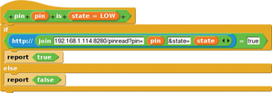 Figure 17: The block description of the pin-reading block.
On the server side, the request handler portion that fields the request looks like what you see in Listing 6. Again, it starts off by breaking up the GET data with the regular expressions seen in Listing 4 (lines 6 to 9).
Listing 6
RPiGPIO.py – Request Handler Part I
01 .
02 .
03 .
04 elif 'pinread'in path: # Read state of pin.
05
06 self.pin = int(m.group(1))
07 self.state = True
08 if m.group(2) == 'LOW':
09 self.state = False
10
11 f = open(ospath + '/return', 'w+')
12
13 GPIO.setup(self.pin, GPIO.IN)
14 if(GPIO.input(self.pin) == self.state):
15 f.write(str(True))
16 else:
17 f.write(str(False))
18
19 f.close()
20 f = open(ospath + '/return', 'rb')
21 ctype = self.guess_type(ospath + '/rpireturn')
22 self.send_response(200)
23 self.send_header("Content-type", ctype)
24 fs = os.fstat(f.fileno())
25 self.send_header("Content-Length", str(fs[6]))
26 self.send_header("Last-Modified", self.date_time_string(fs.st_mtime))
27 self.send_header("Access-Control-Allow-Origin", "*")
28 self.end_headers()
29 return
30 .
31 .
32 .
It then creates a file (filehandle f on line 11), reads the GPIO pin (lines 13 to 17), and writes True or False into the file. Then, it sends all the correct headers back to Snap! and finally returns the contents of f (i.e., True or False).
If you followed everything in this article up to this point, you have imported RPiGPIO.xml into Snap!, and you are running RPiGPIO.py on your Pi, check it out!
You will find this new block in Operators. Drag it onto the workspace and, using the circuit shown in Figure 15, poll pin 24 to see if it is HIGH. Hold down the button on your breadboard and click the block. A speech bubble with the word True should pop up. If you let go of the button and then click the block, False will pop up.

All Together Now
You can also use the script shown in Figure 18 to check that everything is working together. The script loops forever waiting for button presses on pin 24. The first time around, when a user presses the button, the script sets pin 17 (connected to your LED) to HIGH, thus switching it on. Then, it waits until the button is pressed again. When it is, it sets pin 17 to LOW, switching the LED to off. Then, the loop starts again.
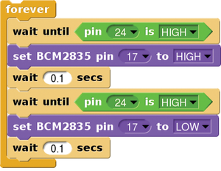 Figure 18: The script waits forever for button presses.
From the users' perspective, it looks like you're using all the computing power of the Pi just to manage an on/off button (Figure 19) – which is true, but I'm sure you can come up with more exciting projects and expansions for the Snap! programming language, right?
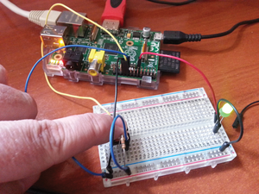 Figure 19: Using all the computing power of the Pi to switch an LED on and off.
Infos
- Squeak Etoys: http://www.squeakland.org/
- Scratch: http://scratch.mit.edu/
- Snap! homepage: http://byob.berkeley.edu/
- GitHub site for Snap!: https://github.com/jmoenig/Snap--Build-Your-Own-Blocks.git
- RPiGPIO, the whole shebang: https://github.com/pbrown66/snap-RPi

